SARVOTTAM
INTERNATIONAL SCHOOL
A Leading Senior Secondary Schoo/ Afl°i/ioted to CBSE

Plot No. 6, Techzone IV, Greater Noida West (U.P.) Tel : 9999600335, 9999600336 Email: info@sarvottamnoida.com www.sarvottamnoida.com

Date: ......................

Please affix a recent color photograph
of the Student

STUDENT APPLICATION FORM (2024-25)

Please affix a recent color photograph
of the Student

Please affix a recent color photograph
of the Father

CLASS .............................. ADMISSION FOR SESSION 20.................................

The form should be filled by the parents

PART A
PARTICULARS OF THE CHILD

Name of the Child: ........................................................................................................ Male / Female: ....................................

Adhaar card number of the child ………………………………………………………………………………………………………………………………….

Date of Birth: (DD/MM/YY) .................................................... Place of Birth................................................................................

Date of Birth (in words): ..............................................Age as on date 1st April 2024……….......... BloodGroup.......................................................

. Name of the Play School/Previous School attended ..................................................................................................................
Please choose 3rd language options from Class 5th and above- Sanskrit / German / French
Please choose 2nd language options for class 9th and 10th - Sanskrit / German / French / Hindi

Religion: ............................................ Nationality: Mother Tongue………………………..

Other languages which the child can speak and understand………….......................Category: (Gen/OBC/SC/ST)

Permanent Address………………………………………………………………………………………………..

Phone No.: ....................................................................... WhatsApp Number: ....................................................................................

Present Address ……………………………………… Email: ……………………………………………………………….

PARTICULARS OF PARENTS / GUARDIANS
FATHER
MOTHER
Name…………….....................................................................................................................................................................

Age:…………………………………………………………………………………………………………………..
Educational Qualification: …………………………………………………………………………………………………… Mobile no.:………………………………………………………………………………………………………………………………….
Email ID: ……………………………………………………………………………………………………………………………………………………………………

Adhaar no : ………………………………………………………………………………………………………………………………………………
Industry type……………………………………………………………………………………………………………...

Name of Organization: …………………………………………………………………………………………………………..
Designation: ……………………………………………………………………………………………………………….
0fficeAddress:
Office address. ………………………………………………………………………………………………………………………..
Office Tel. No. : ……………………………………………………………………………………………………………………….
Monthly Income: ……………………………………………………………………………………………………………..
Nature of Business: …………………………………………………………………………………………………………..
Office Timings:
PARTICULARS OF SIBLINGS

PART B

Or Siblings studying in Sarvottam:

Name Admission no.  (If in Sarvottam) | Age | Studying in School | Class

PART C

MEDICAL HISTORY DECLARATION

Dear Parent,
This form aims to understand the medical and learning needs of your child. Kindly fill the form completely.

- Is he/she on any regular medication? If yes, please mention the details.
…………………………………………………………………………………………………
- Is there any history of delay in developmental milestones? If yes, please mention the details.
…………………………………………………………………………………………………
- Has the child ever undergone treatment for any neurological/ cardiac issue? If yes, please mention the details.
…………………………………………………………………………………………………
- Is there any history of respiratory issues. ? If yes, please mention the details.
…………………………………………………………………………………………………
- Is there any learning difficulty/ disability faced by the child? If yes, please mention the details.
…………..……………………………………………………………………………………..
- In case you have any particular Paediatric/Physician for your child, please share the name and contact number of the doctor …………………………………………………………………………………………………
- Any other information you would like to share with us? (Eg.- Allergies, precautions etc.)
…………………………………………………………………………………………………
- Is there any history of/current emotional or psychological concerns? If yes, please mention the details (Eg- Phobias/ Anxiety etc)
…………………………………………………………………………………………………
By signing this form, I declare that the information I have provided here is true, correct, and complete. I also agree to provide all necessary documents, prescriptions and medical records as and when required by the school.

PART D

QUESTIONS FOR THE PARENTS

1. What are the reasons for preferring 'Sarvottam International School’ for your child? .........................................................

2. What are your expectations from school and teachers? ......................................................................................................

3. How did you learn about 'Sarvottam International School'? ………………………………………………………………………….

4. Nature of family - Joint Family / Nuclear Family / Single Parent: ........................................................................................

5. Describe your child’s personality: ........................................................................................................................................

6. As a parent, how much quality time do you spend with your child and how? .......................................................................

7. If both parents are working, who will be looking after your child at home? ………………………………………

8. Are there any family circumstances that might affect your child's performance? .................................................................

9. What are the areas of your child’s interest?

10. What do you do when your child throws tantrums? .............................................................................................................

11. How independent is your child? ...........................................................................................................................................

12. How do you perceive your role as a parent in the education of your child? ........................................................................

Kindly Note:

- Both parents must accompany the child for interaction.

2. The following documents must be carried at the time of Admission:

* Birth Certificate
* Residential Proof
*Adhaar card of both parent and child
*Previous two years marksheet.
*TC from last attended school (Once the current session gets over)
* Request Letter for classes 9 and above

- Incomplete and incorrect forms will not be accepted.

- Registration amount submitted is not refundable.

- Admission process must be completed within ten days of registration.

.

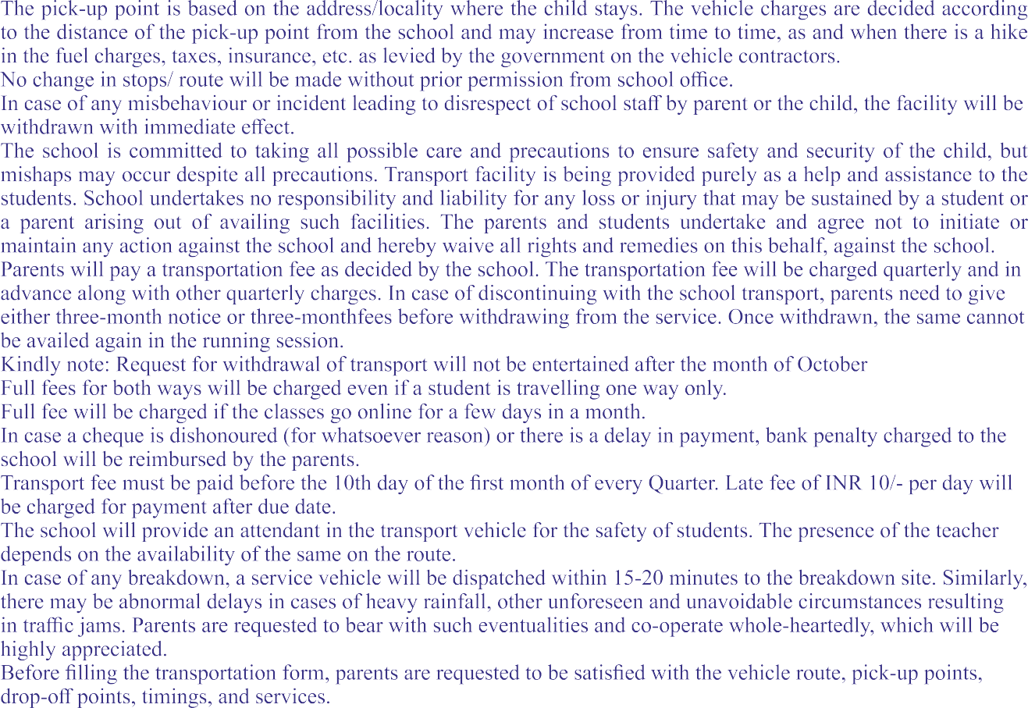

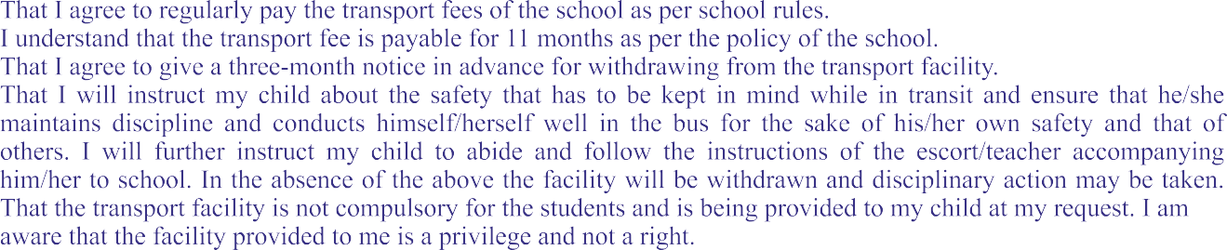
1.
2.
3.
4.

5.
